**Aim**: - To download, install and configure git, jdk, Maven and Jenkins on windows base machine and basic commands.

Download the git from official side:

<https://git-scm.com/download/win>

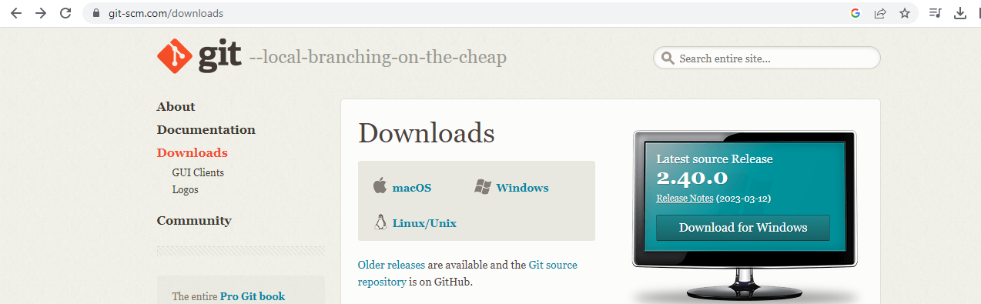

To install git on windows machine:

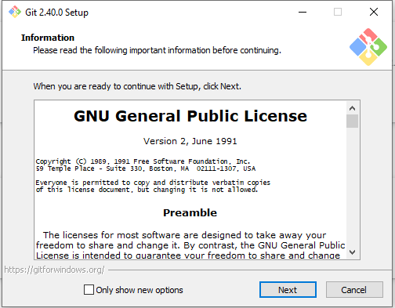

Go to desktop and open the Git bash:

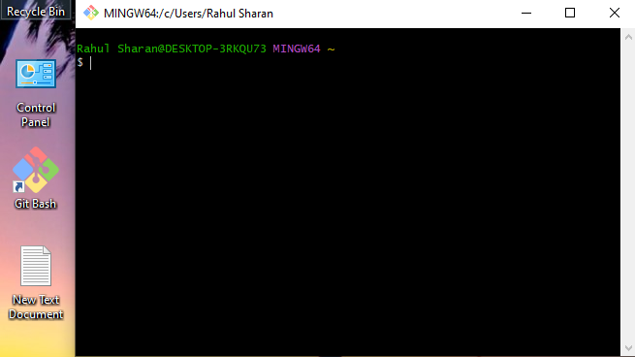

To check the git version:

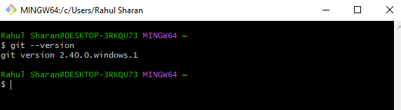

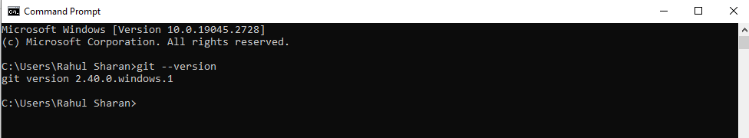

To configure the git:

> git config --global user.name "yoyo"

> git config --global user.mail [rahulsharan512@gmail.com](mailto:rahulsharan512@gmail.com)

> git config --global user.email [rahulsharan512@gmail.com](mailto:rahulsharan512@gmail.com)

> git config --global --list

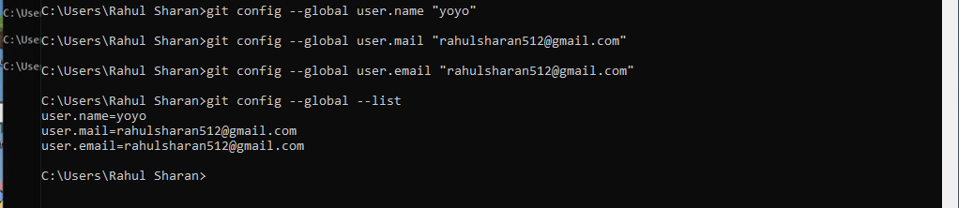

Download the gdk from official side:

<https://www.oracle.com/in/java/technologies/downloads/>

X64 installer

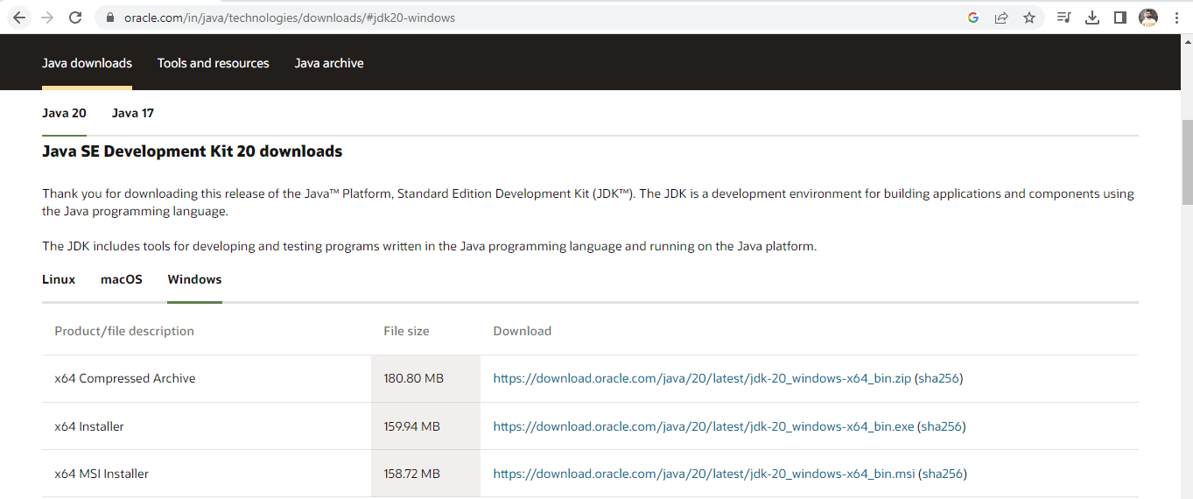

To install gdk on windows machine:

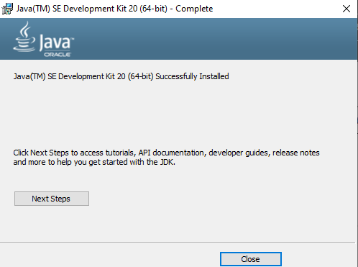

To copy the path from C:\Program Files\Java\jdk-20\bin

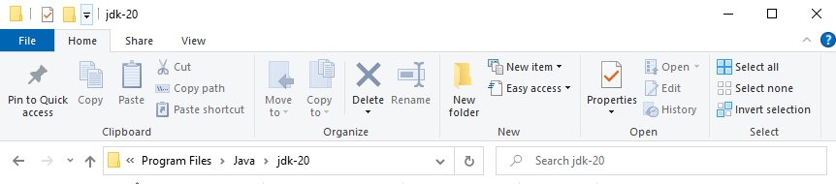

To add the path in Env variable:

C:\Program Files\Java\jdk-20\bin

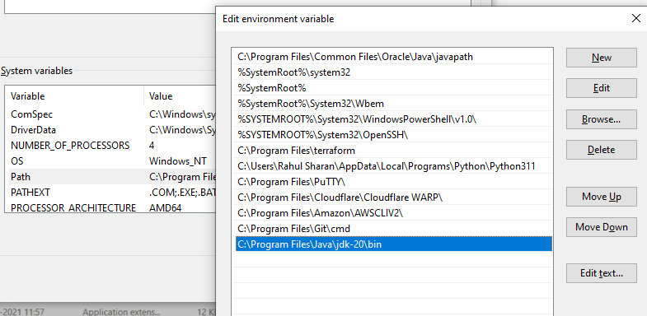

To check the java version:

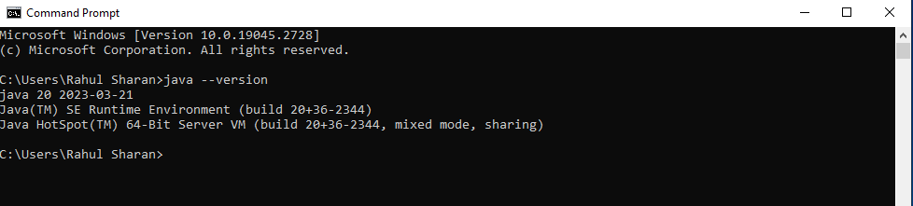

Download the Maven from official side:

<https://maven.apache.org/>

**File**: Binary zip archive- **Link**

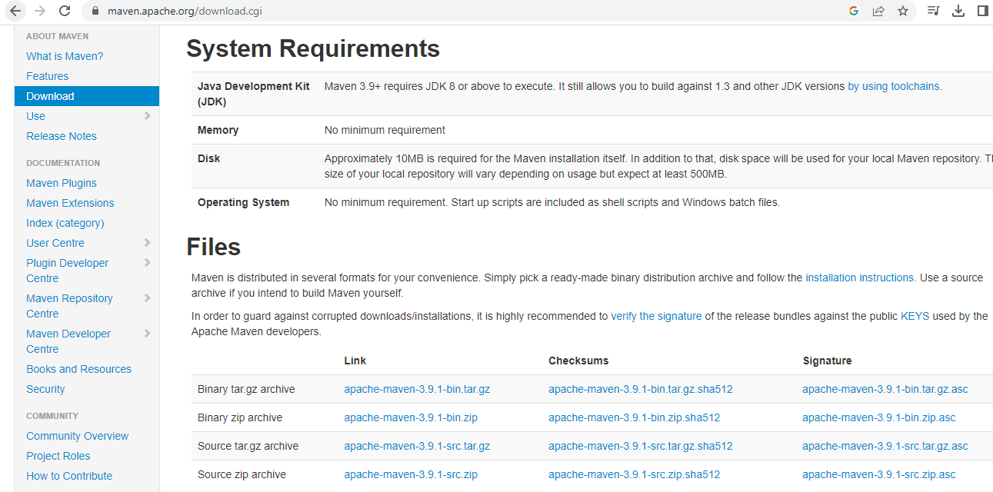

To save the extract file in c drive as a devTool:

Light click on download file>Option>Extract File>Path: C:\DevTool>Ok

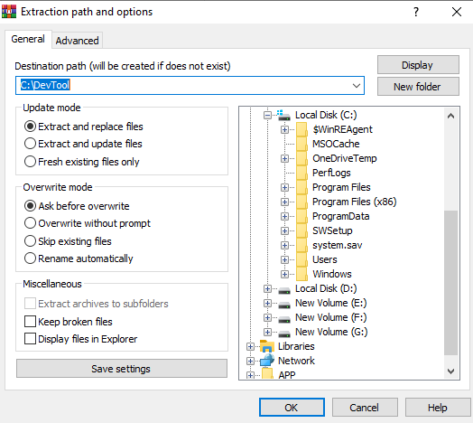

To copy the path C:\DevTool\apache-maven-3.9.1\bin

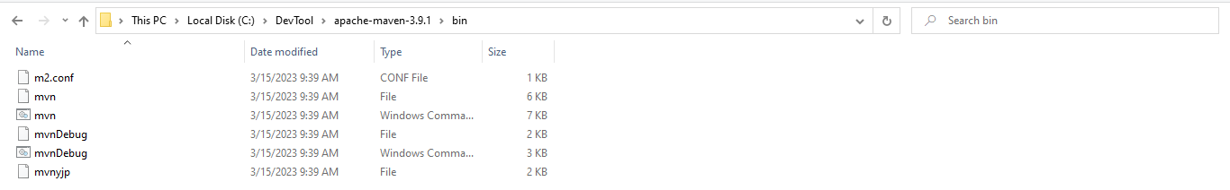

To add the path in Env variable:

C:\DevTool\apache-maven-3.9.1\bin

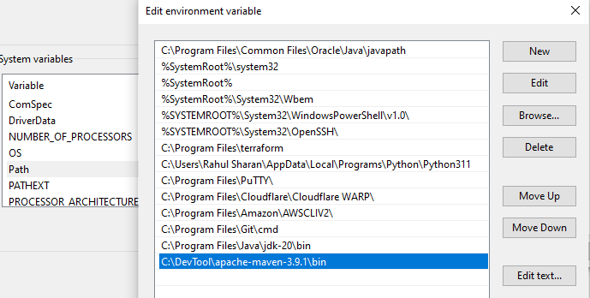

To check the maven version:

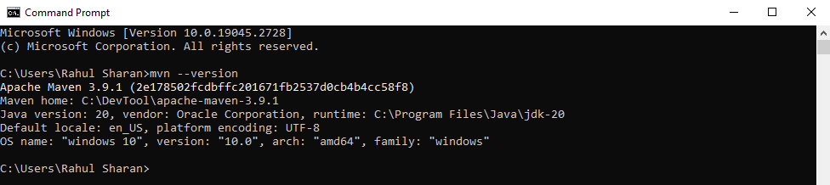

Download the Jenkins from official side:

<https://www.jenkins.io/download/>

Stable (LTS**): Download Jenkins 2.387.2 LTS for: Windows**

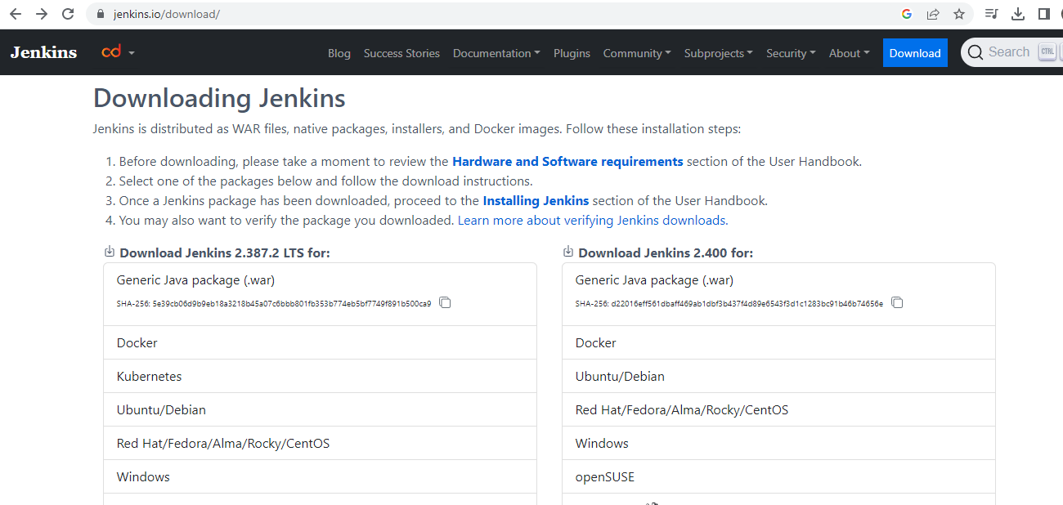

To install Jenkins on windows machine:

Run System as LocalSytem>testport:8080>Select java path C:\Program Files\Java\jdk-17\>next

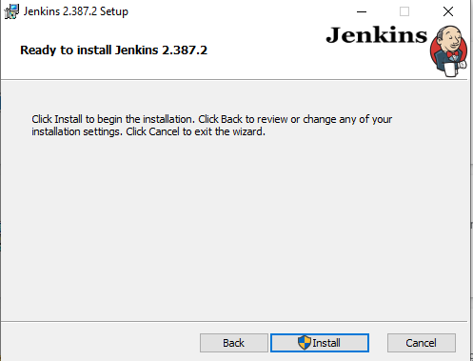

TO sign in the Jenkins portal:

<http://localhost:8080/>

Unlock Jenkins:

C:\ProgramData\Jenkins\.jenkins\secrets\initialAdminPassword

**Administrator password:** e8eb9f2c9b964357bfb972443c0795

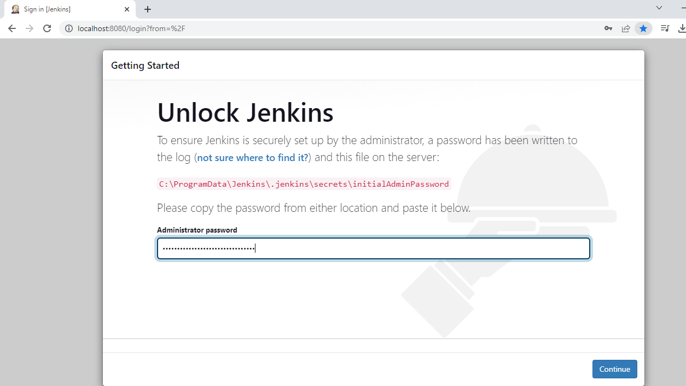

To Customize Jenkins:

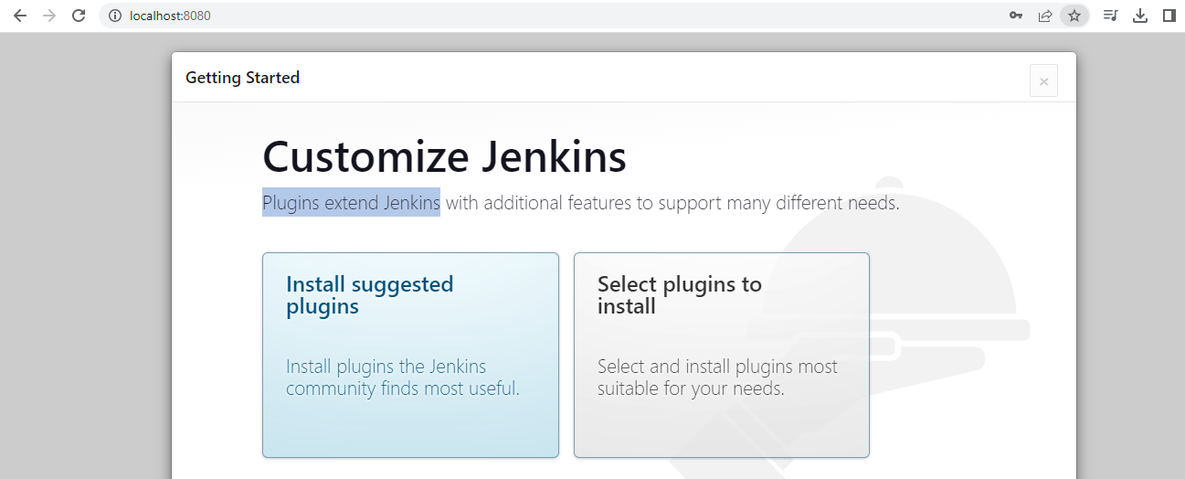

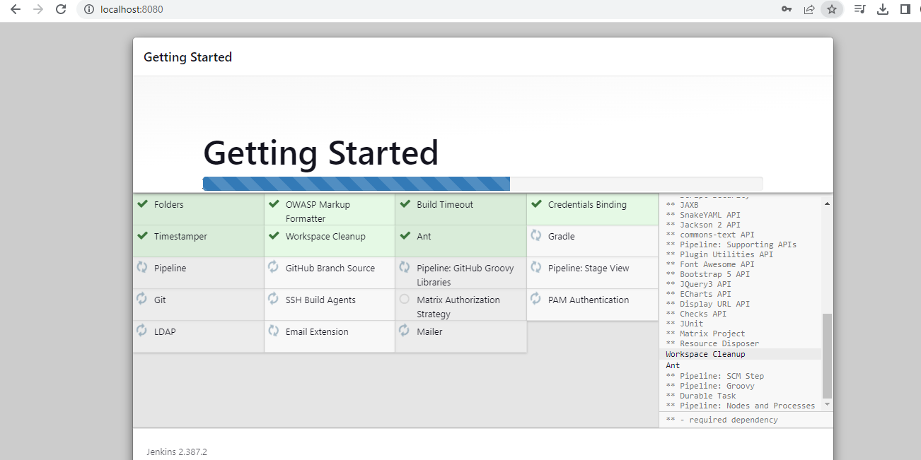

To Create First Admin User:

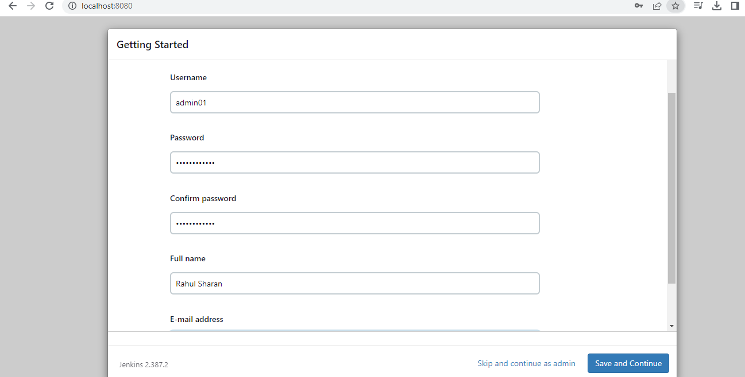

Instance Configuration:

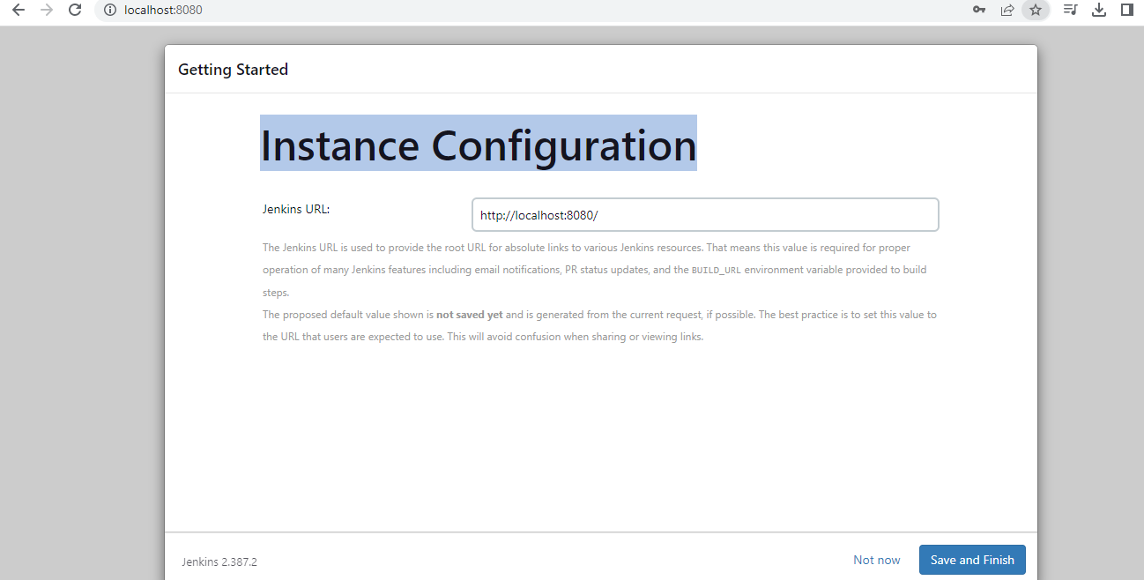

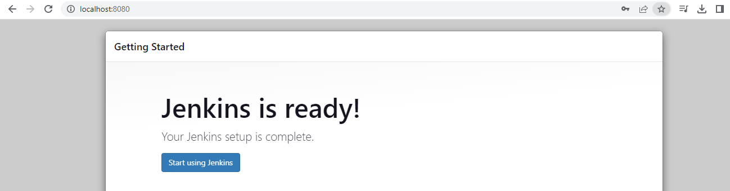

Dashboard of Jenkins:

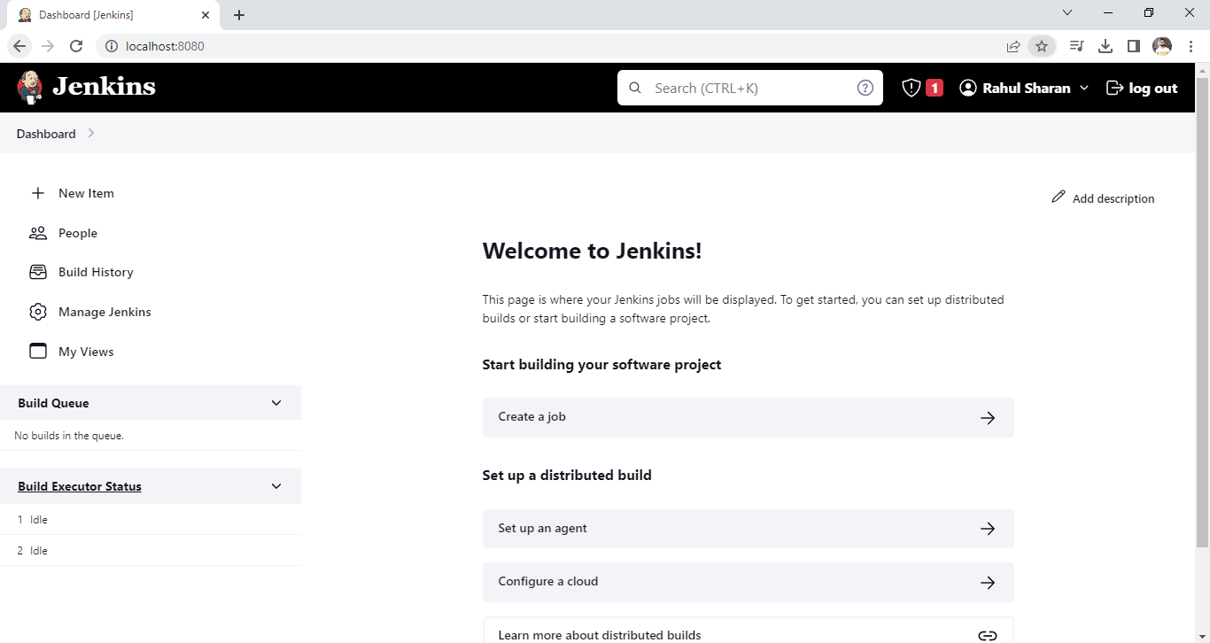

To building project:

Create a job> Enter an item name: Myfirstproject>FreestyleProject>Ok

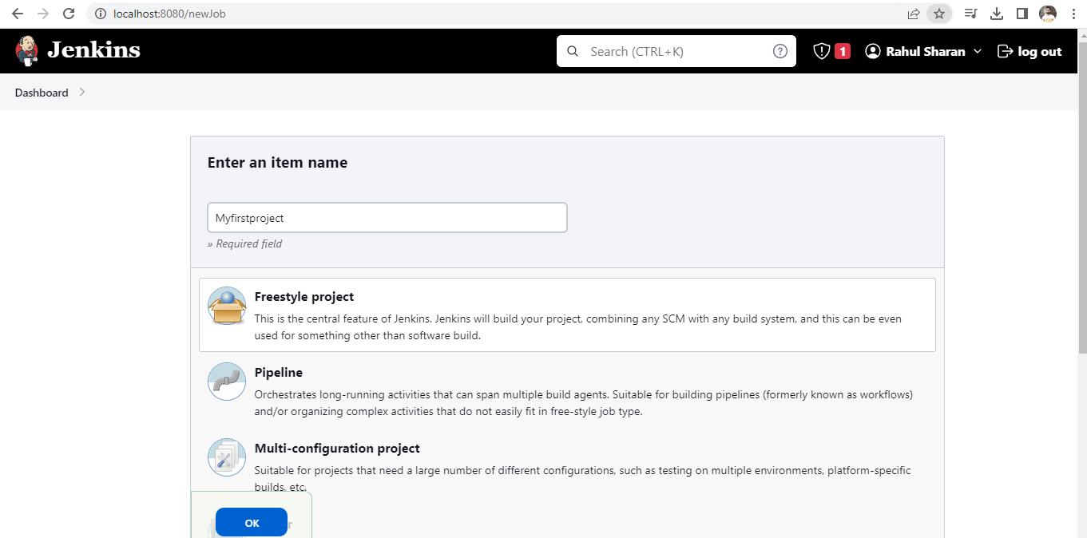

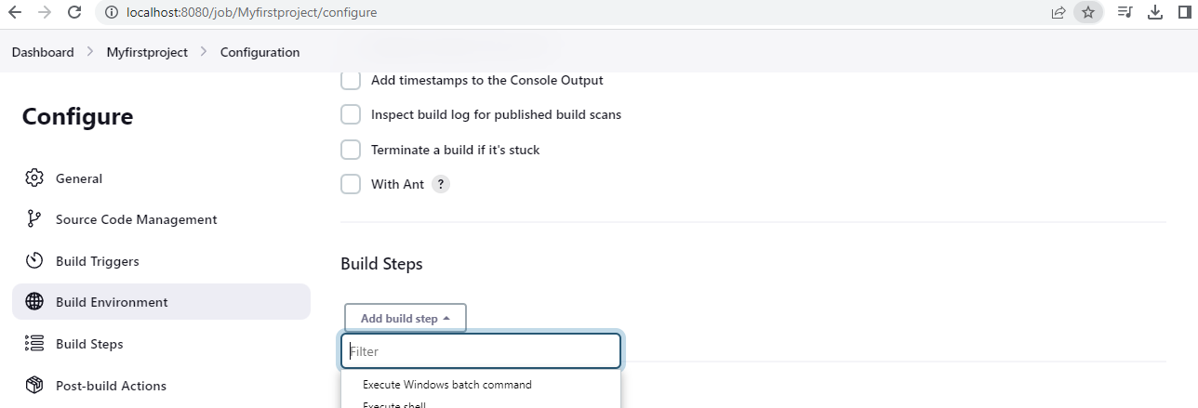

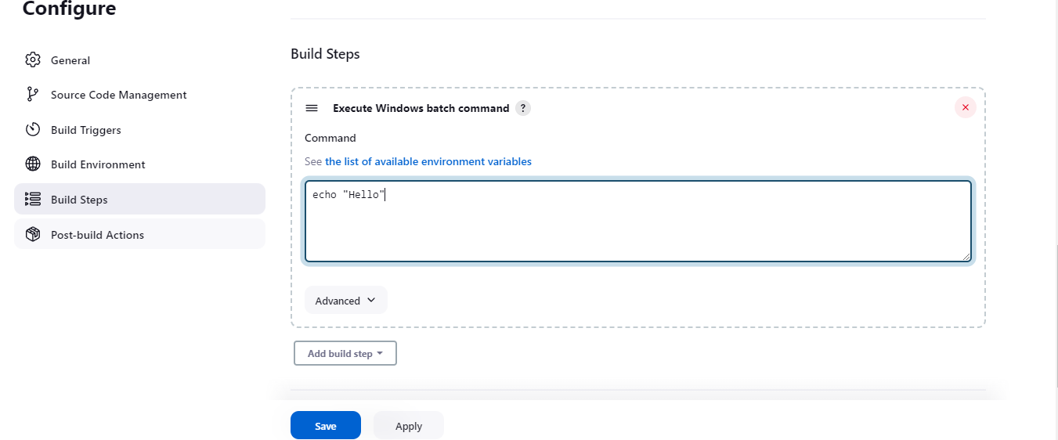

To Build the Myfirstproject:

Right Click on Myfirstproject>select build now option

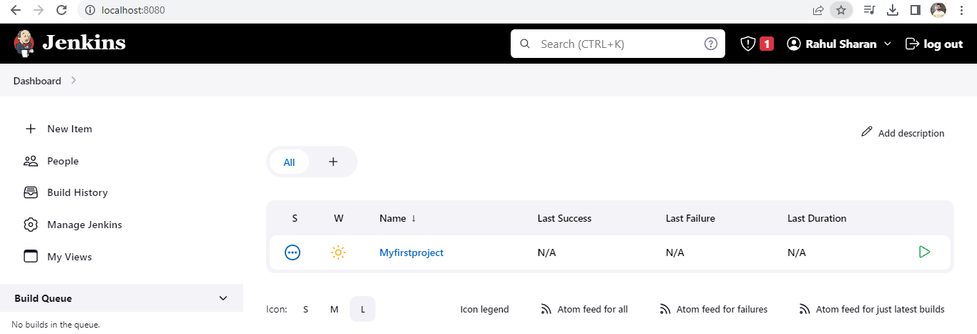

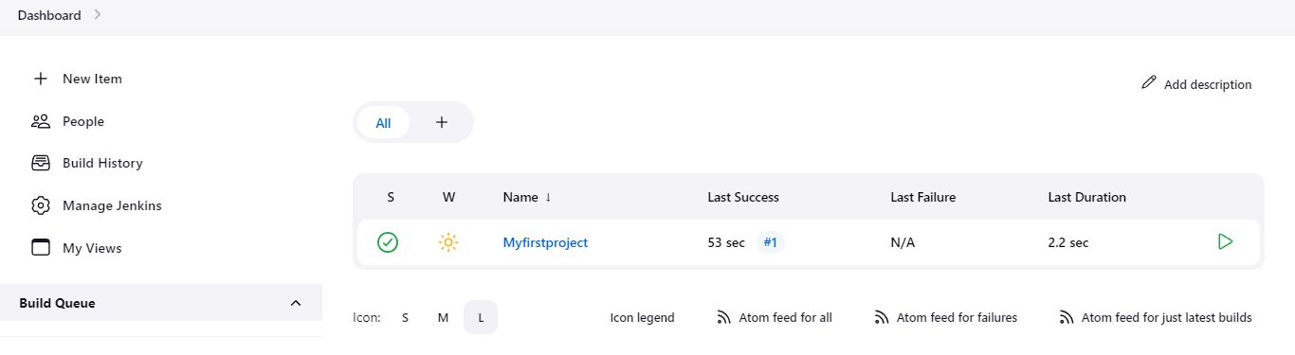

To check the executed task:

Double click on Myfirstproject>Left side click o on console output

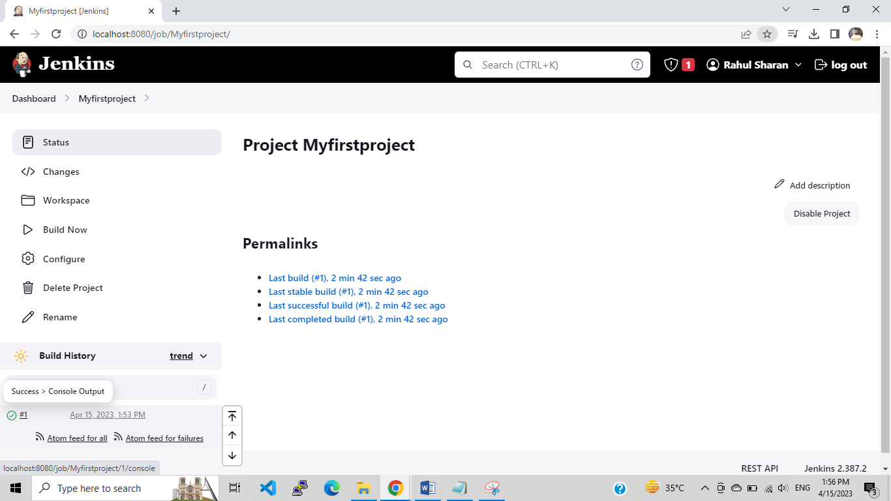

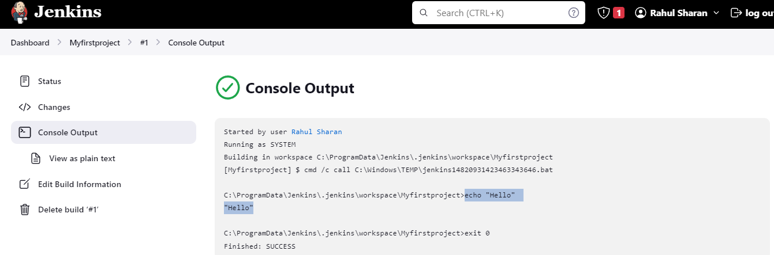

To Copy the Myfirstproject for MynewJob:

+new item>Enter an item name: Mycopyjob>copy from: Myfirstproject>Ok

